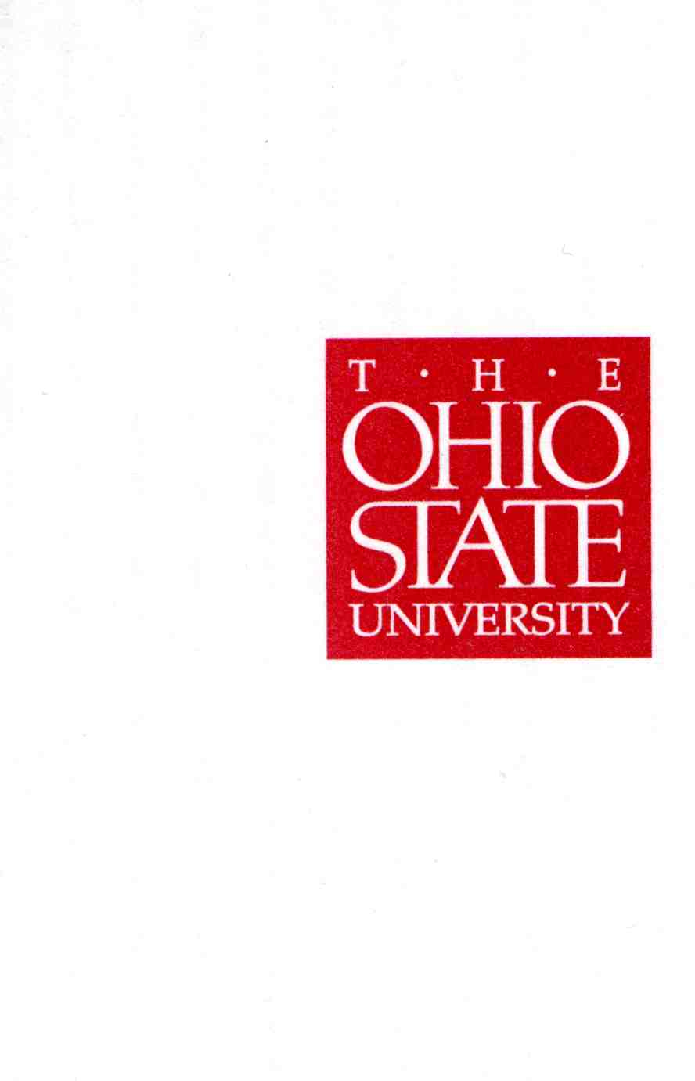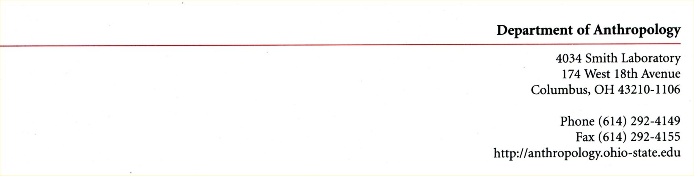

September 28, 2015
Dr. Jay Johnson
Assistant Provost
Office of Academic Affairs

Dear Provost Johnson,

At the suggestion of Bernadette Vankeerbergen, I am requesting that the change in GE status for one of our courses – ANTHROP 4597.03H (The Prehistory of Environment and Climate) - be expedited so that it may take effect by SP16. The course, designed and taught by Professor Rick Yerkes, was last offered in AU 2013, but has failed to make minimum enrollments each time it has been offered since. This course is an important elective for our undergraduate Honors majors (and minor), but we believe that the change in GE status will make it especially attractive to students outside anthropology (e.g., Earth Sciences, Geography). Professor Yerkes believes strongly that if the course can now be advertised as an option for fulfilling the Social Science – Human, Natural, and Economic Resources and Global Studies options (in addition to its status as a cross-disciplinary seminar), there should be enough students interested to achieve the minimum required enrollments for a SP16 offering. For this reason, - and with this appeal - we are requesting that the GE status change be implemented as soon as possible.

Many thanks for your consideration and please do not hesitate to contact me, should you require additional information. I am,

Yours sincerely,

Yours sincerely,

W. Scott McGraw, Professor
Director of Undergraduate Studies

